Lab 04: Using Ethical Hacking Techniques to Exploit a Vulnerable Workstation

Joseph Patrick C. Galvez

American Military University

ISSC262: Red Team and Blue Team Security

Mr. Brian Burnett

7/16/25

Lab 04: Using Ethical Hacking Techniques to Exploit a Vulnerable Workstation

The purpose of this lab is to introduce students to ethical hacking through the use of tools to conduct the five phases of ethical hacking: reconnaissance, scanning, enumeration, exploit, and post-attack activities. The lab consisted of using tools such as Zenmap for reconnaissance, Nessus for scanning, Metasploit for exploitation and post-attack activities.

# Methodology

## Section 1

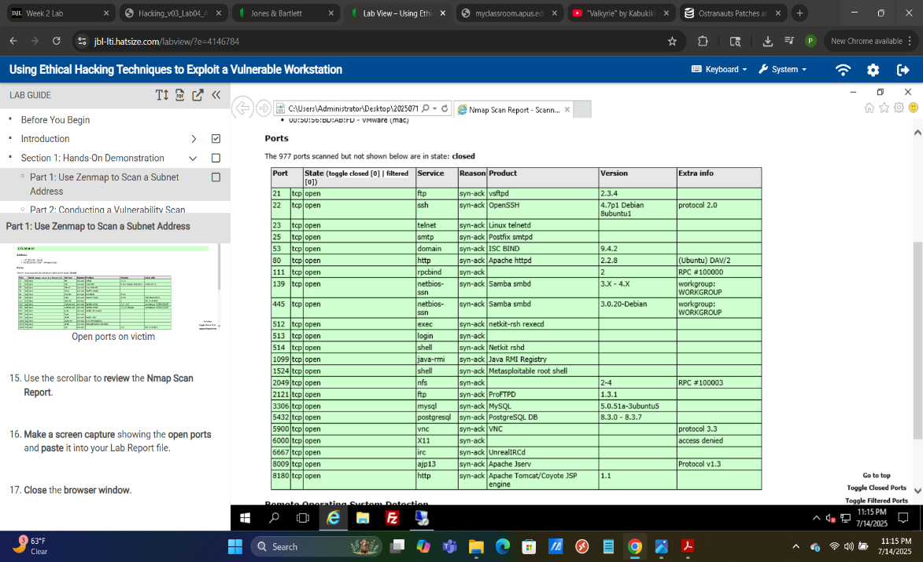[2]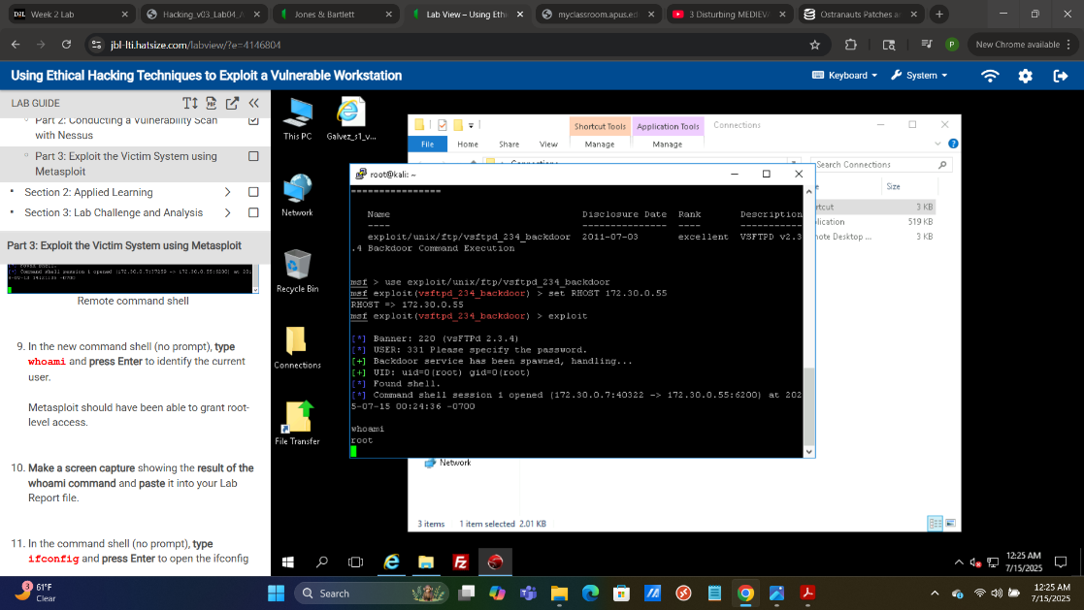[3]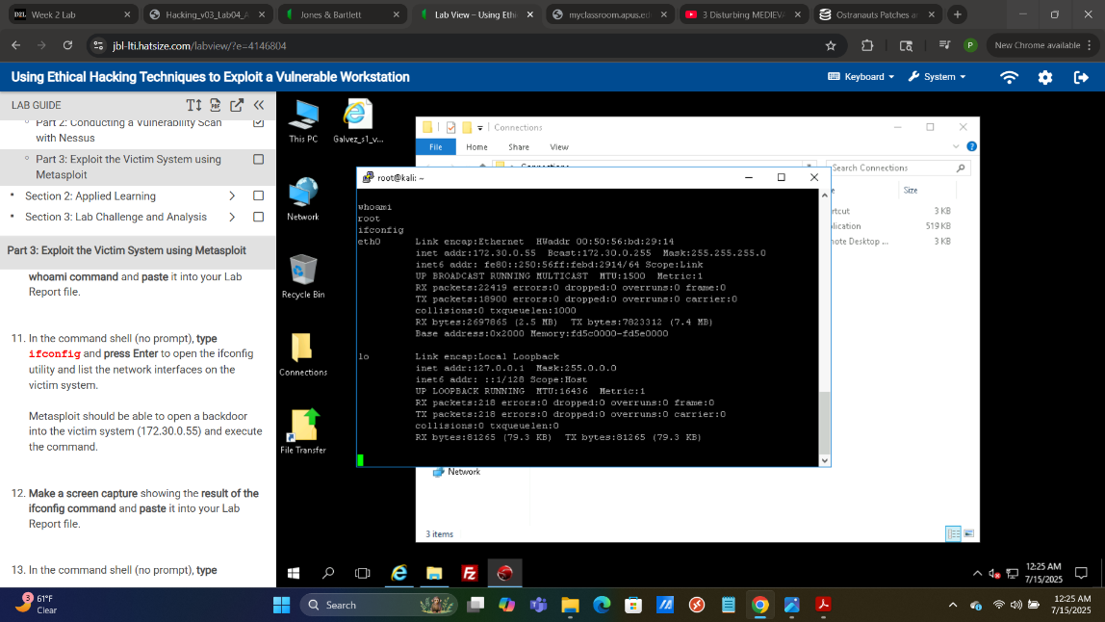[4]

[5]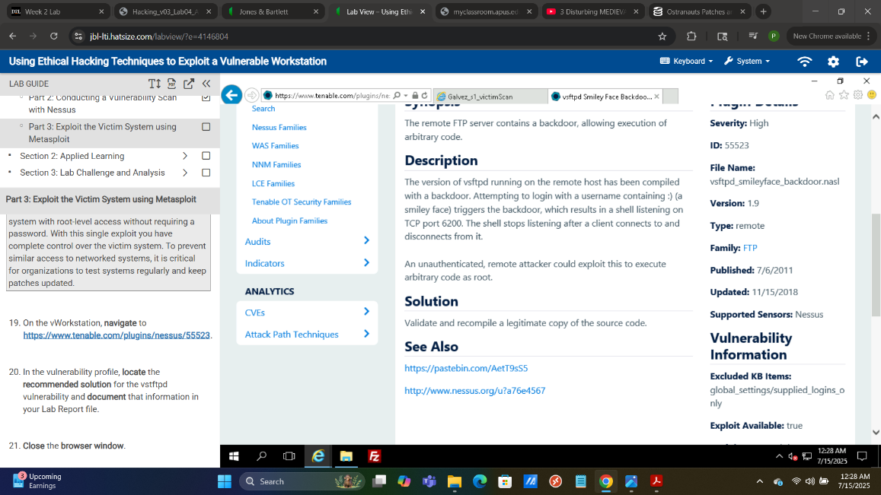[6]

## Section 1 Executive Summary:

Section 1 consists of performing the five phases of ethical hacking to deploy an exploit on the target device, the exploit is a backdoor. Reconnaissance consisted of using Zenmap, which is an application that provides a gui for nmap, to locate open ports. Next Nessus was used for the scanning phase to identify vulnerabilities where 9 were identified. The exploit consisted of using a known vulnerability on vsftpd version 2.3.4. Access was maintained through the creation of a back door by the exploit on the open port 22. Post-attack activities consisted of terminating the command shell and ending the connection to the target device when the iptables rules were recorded.

## Section 2

[7]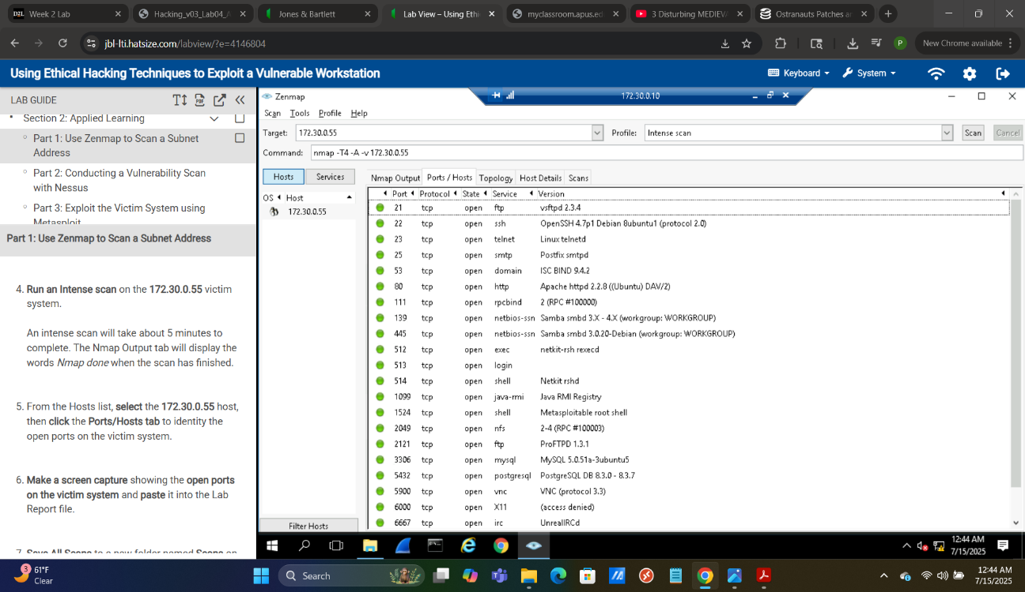

[8]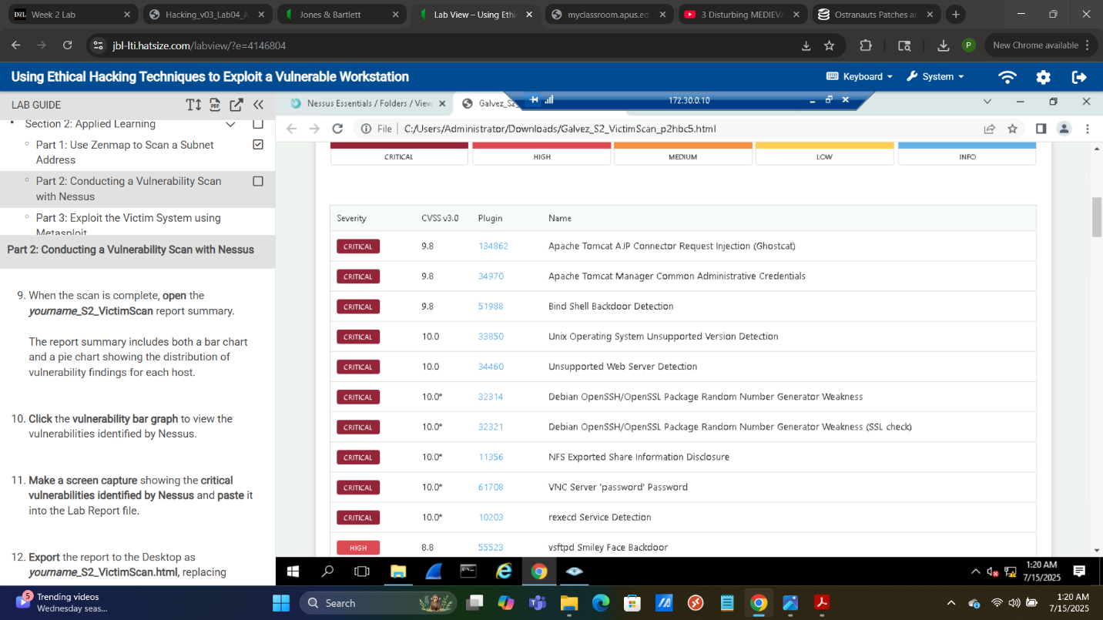

[9]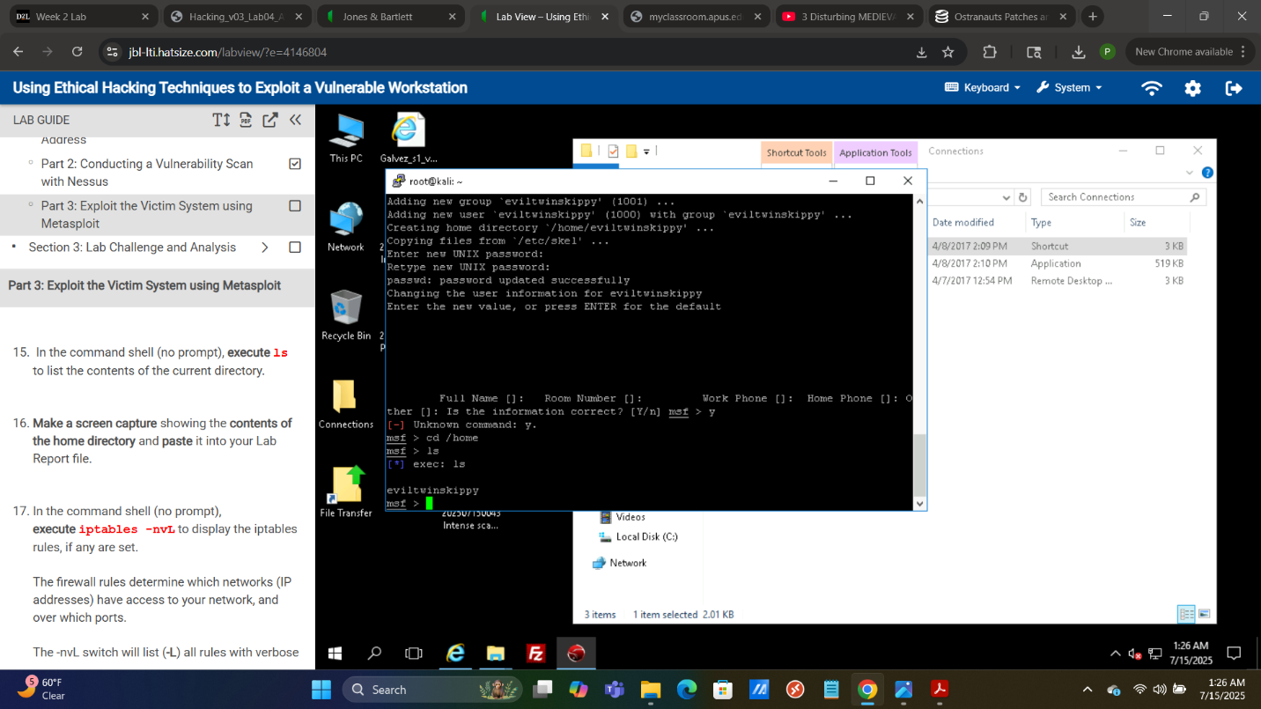[11]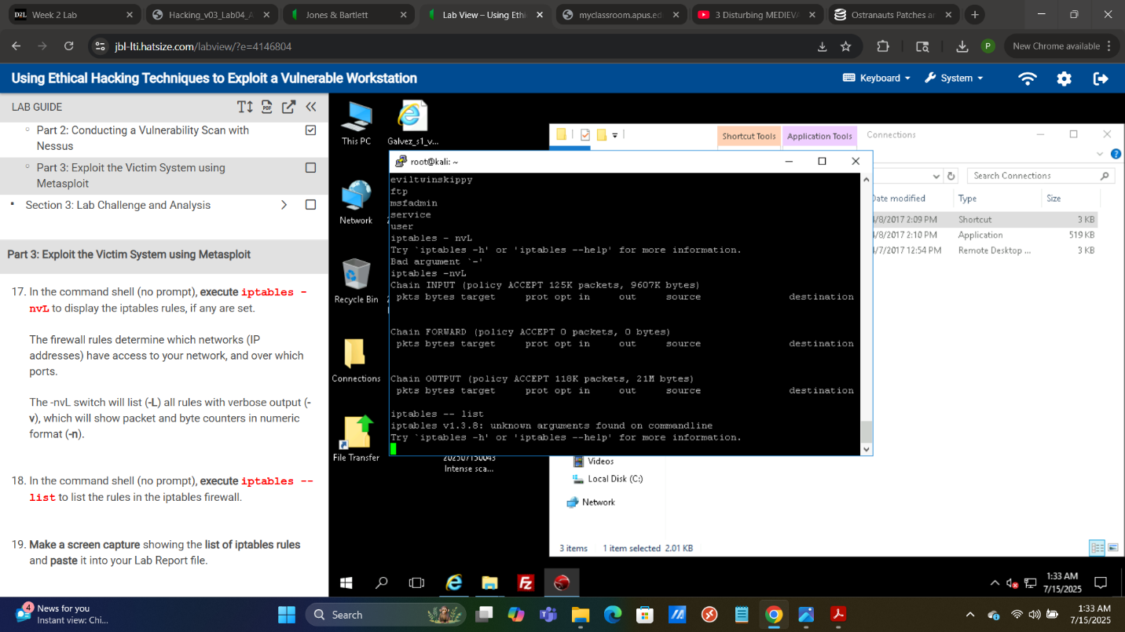[12]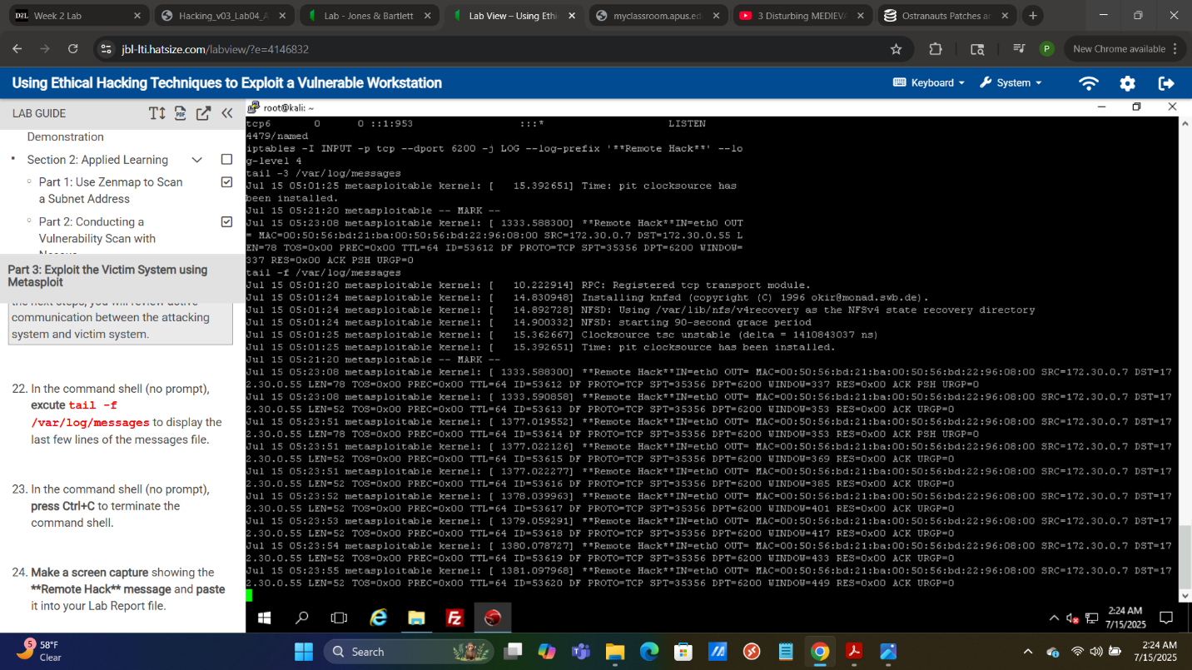[13]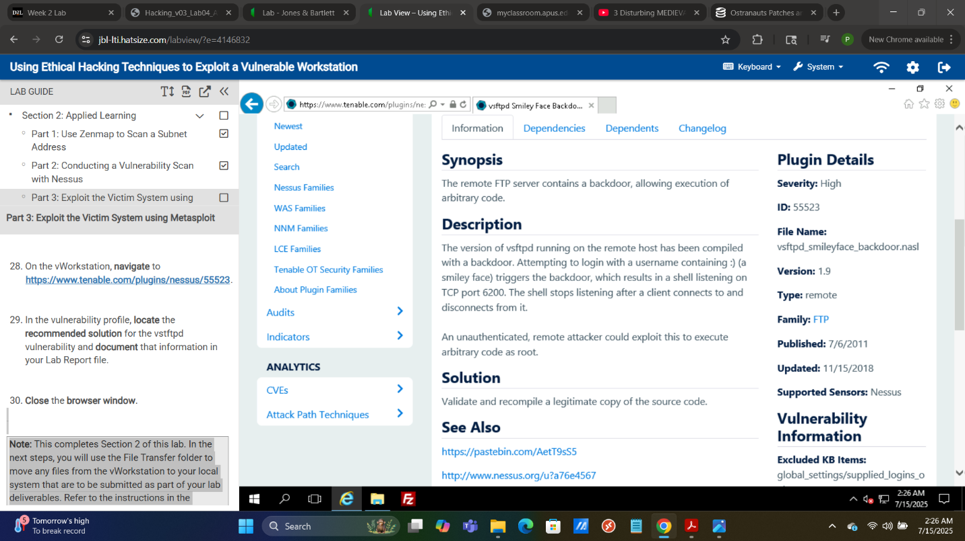[14]

## Section 2 Executive Summary:

Section 2 differs from section one in that the exploit consists of creating a new user as opposed to simply using a backdoor – it is a more established presence. Much like section 1 reconnaissance consisted of scanning for open ports with Zenmap. Scanning was performed with Nessus as well . Metaploit was used to create an exploit which utilized a backdoor much like section 1. However, the method for maintaining access differed in that a new user named “eviltwinskippy” was created using the kali root. The lab simply instructs to exit the PuTTY session once an exploit was ran to display that a remote hack was completed.

References

LTI. (n.d.). *LabVIEW*. JBL. Retrieved July 17, 2025, from https://jbl‑lti.hatsize.com/labview/?e=4149846

1. Figure 1 – Nmap scan on target device
2. Figure 2 – Results of Nessus Vulnerability Scan.
3. Figure 3 – whoami command ran on target computer kali root to confirm that this is the target device.
4. Figure 4 – ifconfig command ran on target computer kali root.
5. Figure 5 – iptables rules of the target device.
6. Figure 6 – ip table rules of the target device
7. Identified vulnerability of the target device.
8. Identified open ports on the target device
9. Vulnerabilities identified by Nessus
10. New user created on the target device
11. Contents of created user directory.
12. iptables rules of created user
13. The “**Remote Hack**” message confirms that the exploit has been delivered.
14. Solution for the exploit used in section 2